Assignment I

Website Project Report

(Gia Hung Tran, 103509199)

**Table of Content**

[**Project Report 4**](https://docs.google.com/document/d/1WWmViQAgu09HwnznYA_Lzov3QDEzfR__jtxSzRbmY2Q/edit#heading=h.3znysh7)

[Summary 4](https://docs.google.com/document/d/1WWmViQAgu09HwnznYA_Lzov3QDEzfR__jtxSzRbmY2Q/edit#heading=h.2et92p0)

[Website Introduction 4](https://docs.google.com/document/d/1WWmViQAgu09HwnznYA_Lzov3QDEzfR__jtxSzRbmY2Q/edit#heading=h.tyjcwt)

[Report Objective 4](https://docs.google.com/document/d/1WWmViQAgu09HwnznYA_Lzov3QDEzfR__jtxSzRbmY2Q/edit#heading=h.qsh70q)

[Website Content 5](https://docs.google.com/document/d/1WWmViQAgu09HwnznYA_Lzov3QDEzfR__jtxSzRbmY2Q/edit#heading=h.1t3h5sf)

[Sitemap 5](https://docs.google.com/document/d/1WWmViQAgu09HwnznYA_Lzov3QDEzfR__jtxSzRbmY2Q/edit#heading=h.4d34og8)

[Introduction Page 5](https://docs.google.com/document/d/1WWmViQAgu09HwnznYA_Lzov3QDEzfR__jtxSzRbmY2Q/edit#heading=h.2s8eyo1)

[Topic Page 5](https://docs.google.com/document/d/1WWmViQAgu09HwnznYA_Lzov3QDEzfR__jtxSzRbmY2Q/edit#heading=h.17dp8vu)

[Quiz Page](https://docs.google.com/document/d/1WWmViQAgu09HwnznYA_Lzov3QDEzfR__jtxSzRbmY2Q/edit#heading=h.3rdcrjn) 6

[Enhancement Page](https://docs.google.com/document/d/1WWmViQAgu09HwnznYA_Lzov3QDEzfR__jtxSzRbmY2Q/edit#heading=h.26in1rg) 6

[Website Style](https://docs.google.com/document/d/1WWmViQAgu09HwnznYA_Lzov3QDEzfR__jtxSzRbmY2Q/edit#heading=h.35nkun2) 7

[Introduction Page](https://docs.google.com/document/d/1WWmViQAgu09HwnznYA_Lzov3QDEzfR__jtxSzRbmY2Q/edit#heading=h.1ksv4uv) 7

[Topic Page](https://docs.google.com/document/d/1WWmViQAgu09HwnznYA_Lzov3QDEzfR__jtxSzRbmY2Q/edit#heading=h.44sinio) 8

[Quiz Page](https://docs.google.com/document/d/1WWmViQAgu09HwnznYA_Lzov3QDEzfR__jtxSzRbmY2Q/edit#heading=h.2jxsxqh) 10

[Enhancement Page](https://docs.google.com/document/d/1WWmViQAgu09HwnznYA_Lzov3QDEzfR__jtxSzRbmY2Q/edit#heading=h.z337ya) 11

[Key Features](https://docs.google.com/document/d/1WWmViQAgu09HwnznYA_Lzov3QDEzfR__jtxSzRbmY2Q/edit#heading=h.1y810tw) 12

[Feature I](https://docs.google.com/document/d/1WWmViQAgu09HwnznYA_Lzov3QDEzfR__jtxSzRbmY2Q/edit#heading=h.4i7ojhp) 12

[Feature II](https://docs.google.com/document/d/1WWmViQAgu09HwnznYA_Lzov3QDEzfR__jtxSzRbmY2Q/edit#heading=h.2xcytpi) 13

[Conclusion](https://docs.google.com/document/d/1WWmViQAgu09HwnznYA_Lzov3QDEzfR__jtxSzRbmY2Q/edit#heading=h.3whwml4) 14

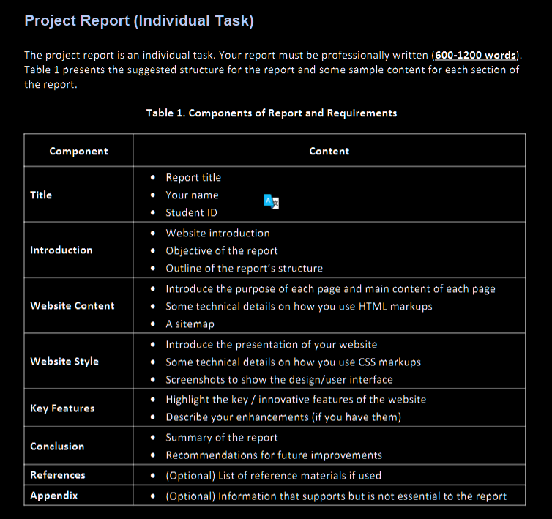

**Project Report**

**Summary**

Website Introduction

Our website, Ruby on Rails, covers general information about the origin, the author, key features, and applications of the technology. The website enhances the user experience with various animations and transitions specifically made to focus the users’ attention on important content. Furthermore, the responsive design ensures that the content across multiple platforms is easily comprehensible. Moreover, there is also a quiz for users to review what they have read. There is an enhancement webpage to list all the enhancements applied to the project which clarifies the way how they are implied.

Report Objective

This report is meant to provide a deep insight into the process of making the project which consists of how HTML and CSS were implied. A general summary of how HTML and CSS are used in the webpage will be provided. Additionally, a detailed analysis of technical issues while building the website will also be delivered.

Report Outline

* Website content
* Website style
* Key features

**Website Content**

Text

Sitemap

Overall, the website is structured into four different pages: the home page(index page), quiz page, topic page, and enhancement page. Each page has its suitable characteristics to improve the user experience. Within the topic page, the table of contents made from the aside tag is to navigate users to which part they want to read.

Introduction Page

This page is to provide readers with short information about Ruby on Rails, which comprises the origin of Ruby on Rails. There is a button right below the paragraph to link to the topic page. There is also a navigation bar on top of the page to navigate through all other pages, and it also appears on other pages. The navigation bar is made with the support of Bootstrap to make it nicer and more convenient for responsive design.

In the body, the content is wrapped inside a section tag. The button and text are separated with different tags button and div tag respectively. At the bottom is the footer which is made from a footer tag and contains some div tags for email.

Topic Page

This page includes three main parts: a section tag for the title, an aside tag, and some article tags for the content. A  table of content is placed inside in the aside tag to clarify what this page has. Inside the article tags, there is the content needed for that subject, and there is one image inside a figure tag with figcaption for the caption of the image. The last article tag has a table to demonstrate the relation between related technologies with Ruby on Rails.

Quiz Page

This page has a list of questions related to the topic page to help users review what they have read. The quiz page involves 5 fieldset tags which are 5 different questions, and all of them are inside a form tag, so all the questions are in just one form. There are two buttons at the bottom of the form. One is to submit the form and the other is to reset it.  Between each fieldset tag, there is an hr tag to separate them and it is to make it easier for users to read.

Enhancement Page

This page has 4 section tags, each of which briefly describes the enhancement integrated on the other pages. The first section is the title of the page, and the fact that the h1 tag is put inside a section tag is to allow the change of its style. Other section tags have one h2 tag and multiple p tags and several types of list tag depending on the content of that section. The content focuses on 3 enhancement transitions, animation, and responsive design.

**Website Style**

Introduction Page

The website has a template color of pink and red, and so does the navigation bar. The navigation bar comprises mainly red color and the color of the text is white to make it contrast. With the attribute by Bootstrap, the navigation bar can be responsive without the interference of media properties like normal responsive design, and the amount of CSS work can be reduced.  Additionally, when the navigation bar is on which page, the element corresponding to that page will be on active status which means that the color of the text will be white.



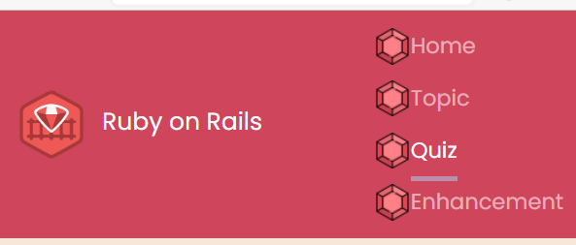

The paragraph and the header are put into a div tag which is styled with a border shadow on the left to make a line to that side of the section. The background of the button is set to none, and the border-radius is 25px to make the corner more round. Furthermore, there is a transition of the button, when it is hovered by moving along the y-axis, changing the color of the text and border.

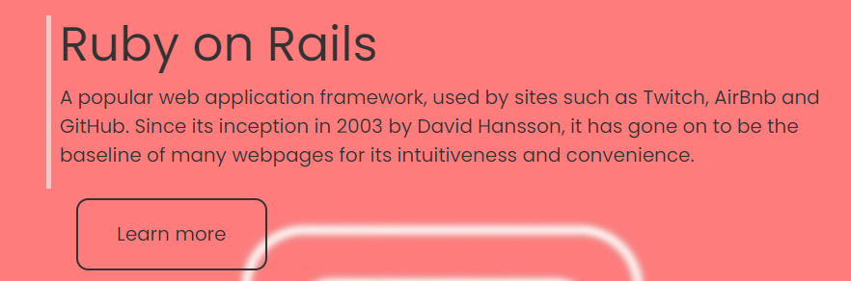

The footer is also responsive. The flex display and justify-content of space-around to make the space between each contact section equal



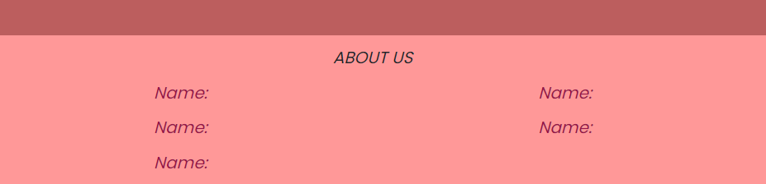

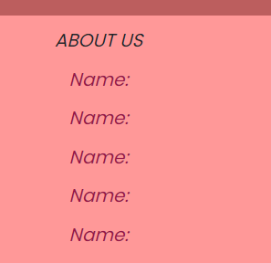

Topic Page

This page also follows the main color template, and the header is styled with shorthand to make it bold and italic. The float property of the aside tag is set to the right so the article tags below can be displayed parallelly with the aside tag.

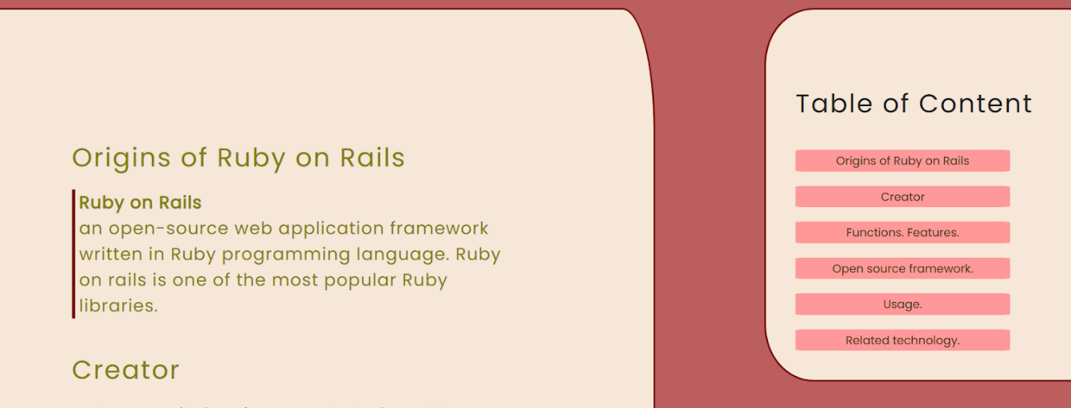

The table at the bottom of the page is also made with a different background color for the heading and data. The overflow-x property of the table is set to scroll so that when on a small screen user can just scroll the table instead of the whole page.

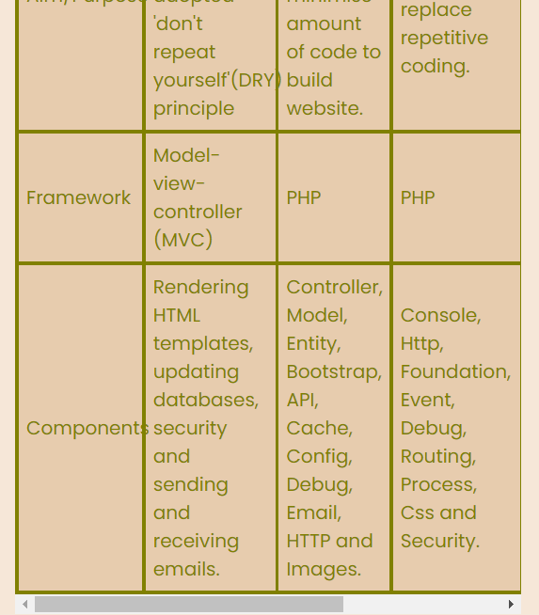

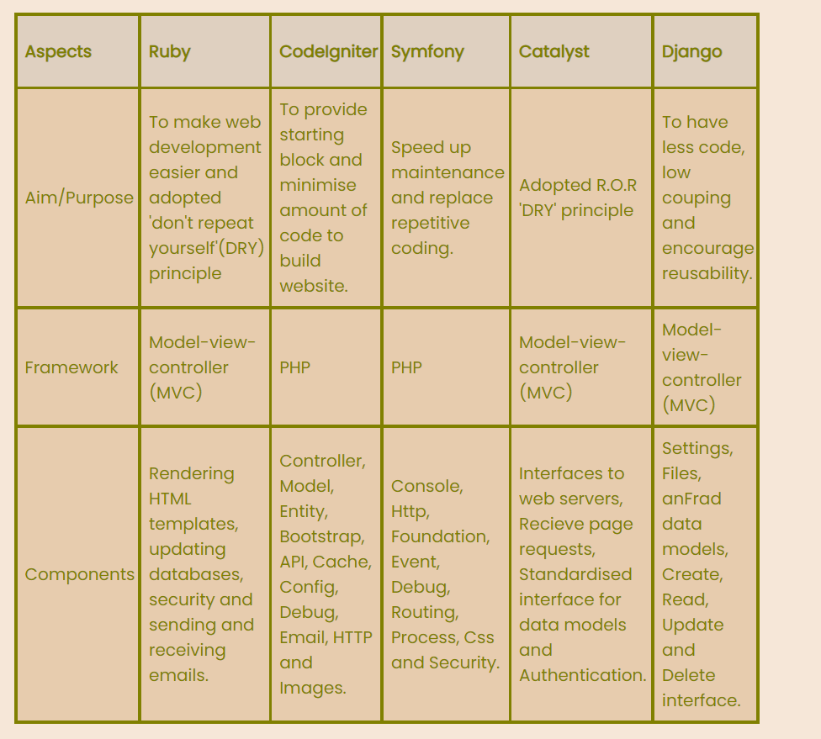

Quiz Page

The page background is set to a color whose hex code is #F6D7E8. The hr tag is mainly styled border-style of dotted and margin auto to make it centered and dotted. Each fieldset will undergo a transition such as moving a bit when being hovered, which is the same with the buttons at the bottom of the page.

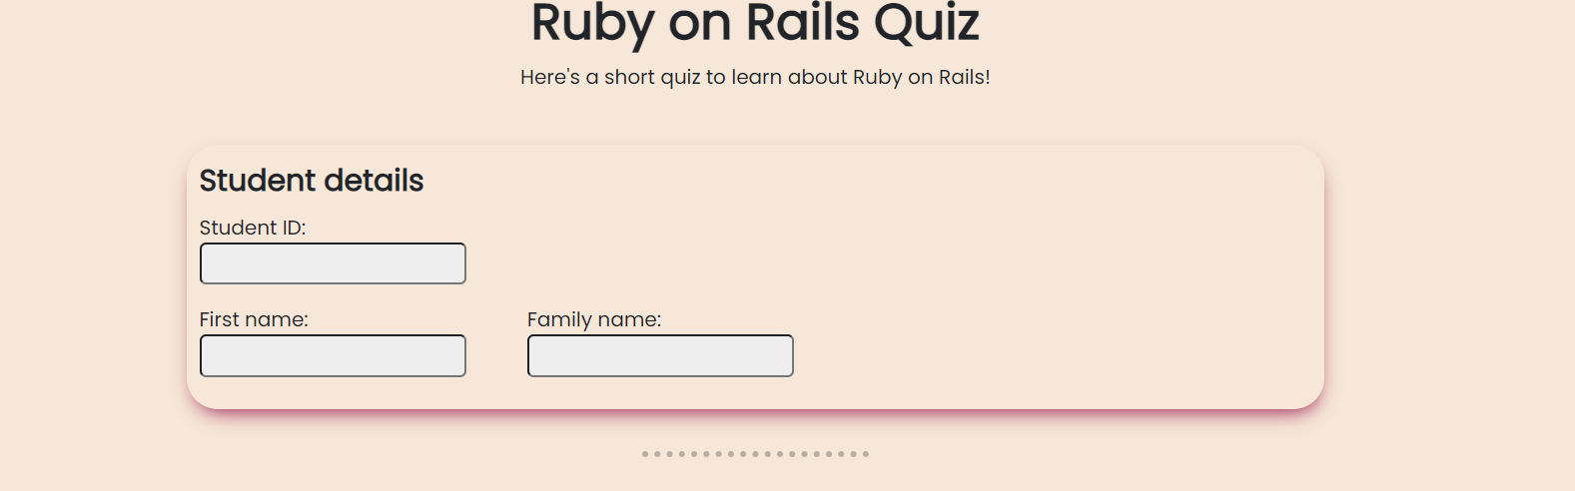

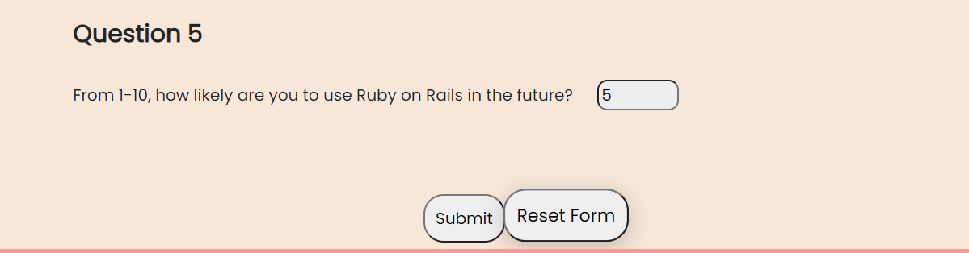

Enhancement Page

This page just includes a basic design with the same background color as the quiz page. Each section of the content is placed inside a section tag to style it. The border-radius of each section is 25px, so it would become more round at the corner and easier to read.

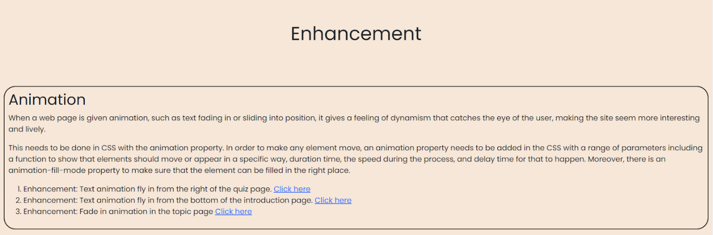

**Key Features**

Responsive design

The navigation bar is a responsive design with the use of Bootstrap. Navbar-expand-md is a class provided by Bootstrap to help style the navigation bar. Navbar, and navbar-dark are to style the elements inside the nav tag, while navbar-expand-md guarantees that when the screen shrinks down to the size of a phone, all the elements of the nav bar will display on just one column.



The footer is also responsive when the screen shrinks down to medium, and small screen size it displays in 2 columns and 1 column respectively with the application of display grid and grid-template-columns property.

Moreover, on the topic page, the aside tag is also responsive  thanks to the media property to delete the float property and make it fit into a small

screen.

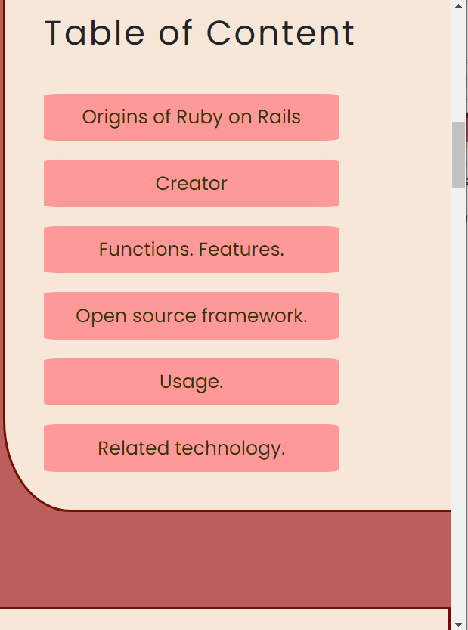

Animation and transition

There are several animations and transitions throughout the webpage. This can be achieved with animation and transition properties. There are some functions to specify how transition works like scaleX, scaleY, transform, etc. Animation is a bit different when there needs to be a @keyframes rule to direct how animation would emerge.



**Conclusion**

Overall, this report has covered the general CSS and HTML that have been implied in the webpage. the. Key features of the webpage are responsive design and animation which enrich the user experience. How the enhancements are implied is also depicted with some technical details on CSS.

Despite the integration of those enhancements, the webpage still does not suffice. It still lacks an appropriate background for the index page when the color of the image does not contrast enough to the text, and the responsive design of every page isn’t optimized because there are still some flaws when the screen diminishes.